**Using SE84 to find BADI**

1. Find package for a T-code.Go to SE93, provide t-code name(VA01), display.

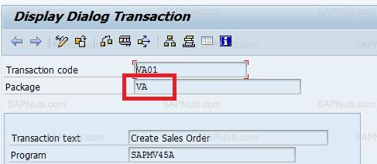

1. Go to SE84, expand enhancements, expand Business Add-ins and select definition.

Provide package name and execute, you will find list of BADI`s.

